**OSINT and Recon Lab**

**Table of contents**

1. Lab Objective 3

2. Tools Used 3

3. Recon Steps and Commands 3

4. Conclusion 6

5. Recommendations 6

**List of Figures**

Figure 3.1 Shows recon commands for certificate_transparency 4

Figure 3.2 Shows recon commands for brute_hosts 4

Figure 3.3 Shows recon scan results for both outputs 4

Figure 3.4 Shows shodan scan results 5

Figure 3.5 Shows maltego graph 6

**List of Tables**

Table 3.1 Shows shodan results 5

# Lab Objective

The purpose of this lab is to perform Open-Source Intelligence (OSINT) gathering and reconnaissance on a target domain (example.com) using tools like Recon-ng, Shodan, and Maltego. This helps in identifying sub-domains, exposed services, and potential attack surfaces.

# **Tools Used**

* Recon-ng – Automated web reconnaissance and sub-domain enumeration.
* Shodan – Search engine for internet-connected devices to identify exposed services.
* Maltego – Visual link analysis and data correlation for network and domain intelligence.

# **Recon Steps and Commands**

***Step 1:*** Recon-ng – Sub domain Enumeration

1. Open Recon-ng

***recon-ng***

2. Create a new workspace

***workspaces create example_recon***

4. Load the sub-domain enumeration modules

***1. modules load recon/domains-hosts/certificate_transparency***

***options set SOURCE example.com***

***2. modules load recon/domains-hosts/brute_hosts***

***options set WORDLIST /usr/share/dnsmap/wordlist_TLAs.txt***

5. Run the module

***run***

6. Show the results

***show hosts***

1. Results :

module : certificate_transparency and brute_hosts  
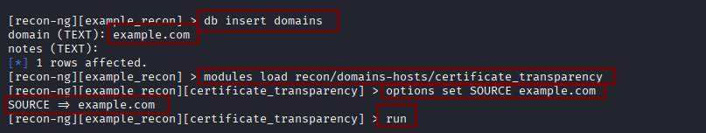

#### Figure 3.1 Shows recon commands for certificate_transparency

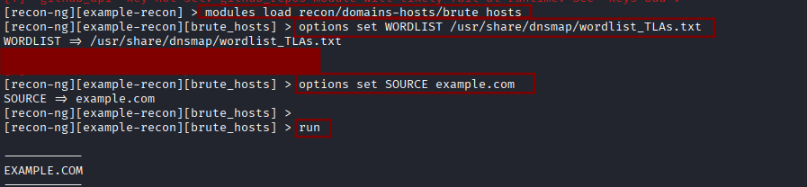

#### Figure 3.2 Shows recon commands for brute_hosts

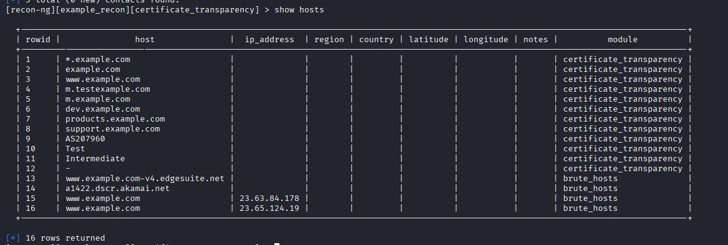

#### Figure 3.3 Shows recon scan results for both outputs

***Step 2:*** Shodan – Exposed Service Discovery

***Tool: Shodan***

***Type command : Apache country :US***

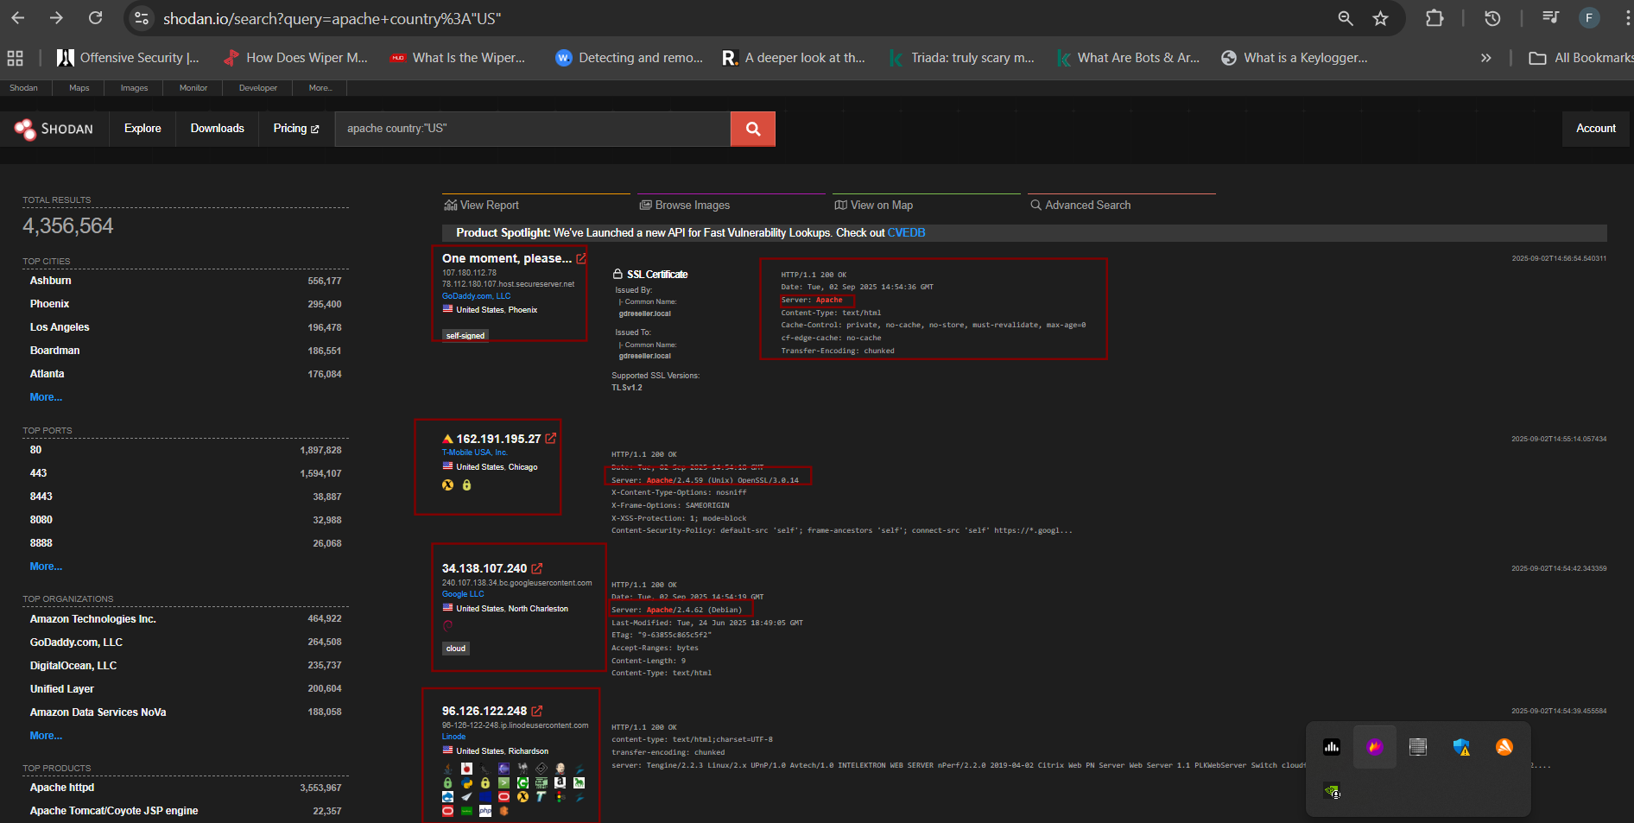

#### Figure 3.4 Shows shodan scan results

| **Sub-domain/Host** | **IP Address** | **Notes** |
| --- | --- | --- |
| host.secureserver.net | 107.180.112.78 | GoDaddy.com LLC, Phoenix (Apache server, self-signed SSL) |
| Unknown | 162.191.195.27 | T-Mobile USA, Chicago (Apache/2.4.59 on Unix, OpenSSL 3.0.14) |
| content.com | 34.138.107.240 | Google LLC, North Charleston (Apache/2.4.62 on Debian) |

##### Table 3.1 Shows shodan results

***Step 3:*** Maltego – Visual Mapping (Optional)

1. Open Maltego CE

***maltego***

1. Create a new graph
2. Entity: www.example.com
3. Run transforms: Used transforms like To Domain, To DNS Name, To Website, and To

Entities to map relationships.

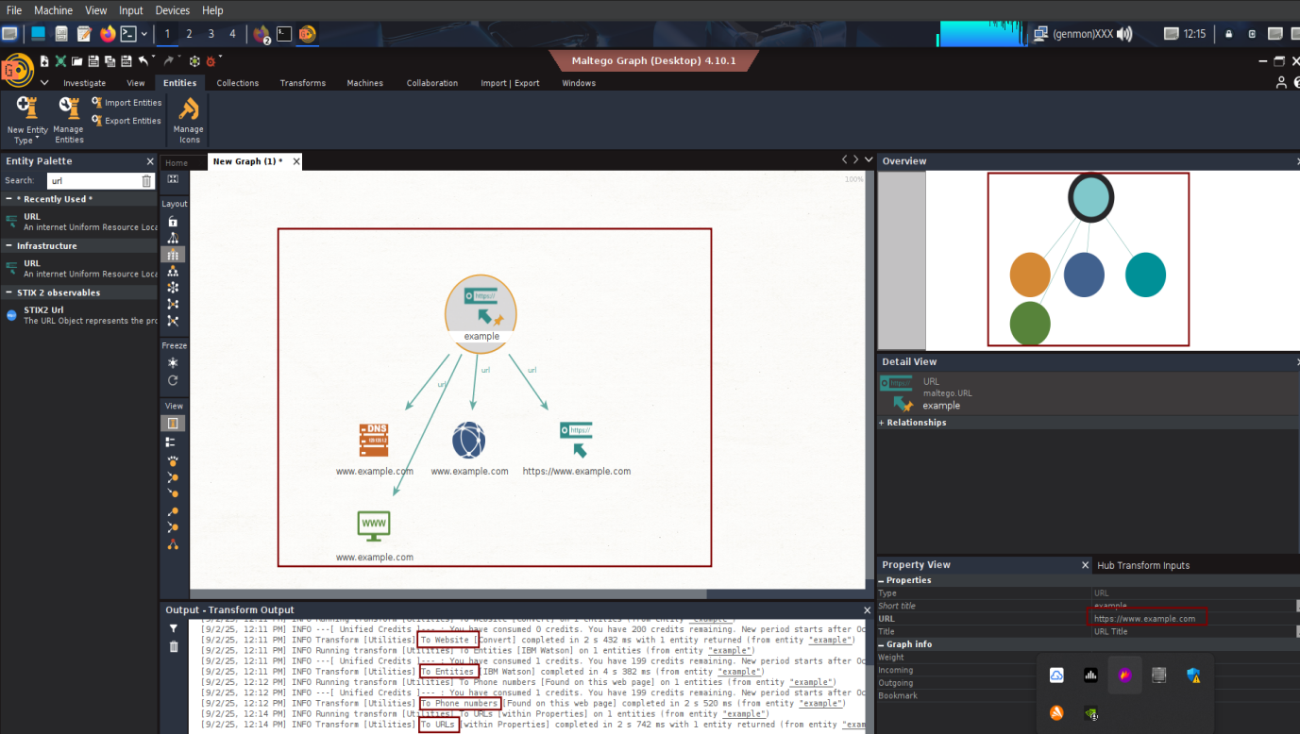

#### Figure 3.5 Shows maltego graph

# Conclusion

* Recon-ng revealed sub-domains and associated IP addresses for the target domain.
* Shodan identified exposed Apache services in the US, including SSL-enabled and admin-accessible servers.
* Maltego provided a visual mapping of network relationships.

# Recommendations

* Periodically perform sub-domain enumeration to detect new assets.
* Monitor exposed services using Shodan or similar tools for vulnerabilities.
* Use Maltego graphs to visualize relationships for comprehensive network mapping.